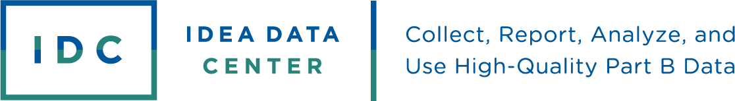

EDFacts Modernization:
Planning Questions to Consider
EDFacts modernization is transforming the way states submit federal reports through the new EDPass system. While the long-term benefits of this transformation will include more accurate and timely data, states will initially have to contend with significant changes to file submission schedules and the Office of Special Education Programs’ (OSEP) data quality review process. With these changes on the horizon, the IDEA Data Center (IDC) recommends taking some time to review your state’s data processes to ensure a smooth transition.
To help you conduct this review, we have developed a series of guiding questions that you and your state team can use to prepare for these changes. We grouped these guiding questions into four areas where you are most likely to see processes change significantly.

Data Team
The state’s EDFacts coordinator will grant individuals access to the new EDPass system, thus the ways you collaborate to submit data may change. Consider the following questions about how your state’s data team can maximize the way you work together within the new system.
Question | Response
How do you currently work with your state’s EDFacts coordinator?
How might you enhance your collaboration to improve data quality?

EDPass Processes
In the new system, the EDFacts coordinator can also grant access for specific tasks. As you plan for submissions with your EDFacts coordinator, use the following questions to consider who should have each role within the EDPass process.

Question | Response
Who will upload data?
Who will review data quality edit checks?
Who will complete necessary reuploads and deletions?
Who will be responsible for data notes?
Who will submit the final data once updates and data notes are complete?

Timelines
With the new EDPass system, deadlines are changing. Most file submission dates will be later, and you will need to include data notes at the point of submission. Because of these changes, it is a good idea to review your internal timelines to ensure a smooth transition. Use the questions below to plan out some of these changes.

Question | Response
How do you plan to work with local education agencies (LEAs) to collect any unexpected data notes the EDPass system requires for data submission?
How will the change to the submission and data quality schedule affect your other processes? Do you need to make any schedule changes?
What systems, routines, protocols, etc. do you need to put in place now to meet this new timeline and ensure high-quality data in the future?

Data Quality Processes
With the greater emphasis on data notes and the addition of a pre-submission data quality review process in the EDPass system, IDC recommends having discussions about who should be involved in preparing data notes, reviewing LEA data, and tracking data quality concerns as you update these processes. Use the questions below as you review your data quality processes.

Question | Response
Who will need to be part of the data quality note creation and collection process?
How will you need to update the data review process with LEAs?
How will you track potential data quality concerns?

The IDEA Data Center (IDC) created this publication under U.S. Department of Education, Office of Special Education Programs grant number H373Y190001. Richelle Davis and Rebecca Smith serve as the project officers. The information herein does not necessarily represent the positions or policies of the U.S. Department of Education. No official endorsement by the U.S. Department of Education of any product, commodity, service, or enterprise in this publication is intended or should be inferred.
This product is in the public domain. Authorization to reproduce it in whole or in part is granted.
www.ideadata.org

