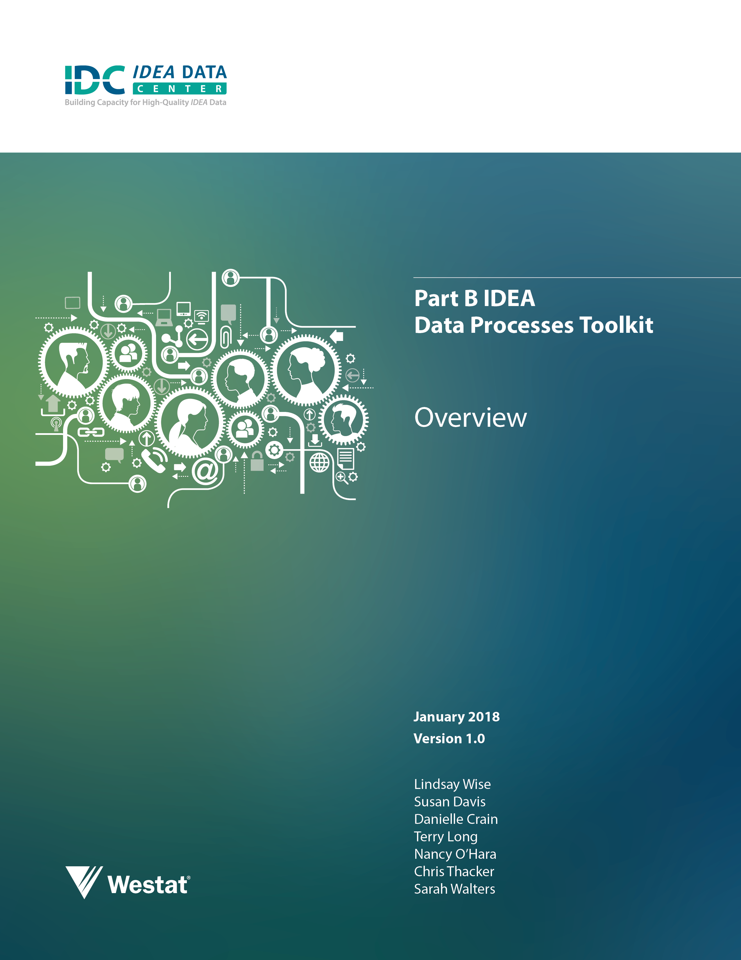
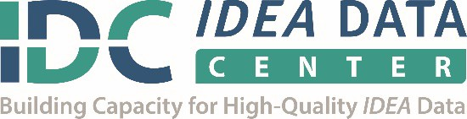
The IDEA Data Center (IDC) created this document under U.S. Department of Education, Office of Special Education Programs Grant No. H373Y130002. Richelle Davis and Meredith Miceli serve as the project officers. The views expressed herein do not necessarily represent the positions or policies of the U.S. Department of Education. No official endorsement by the U.S. Department of Education of any product, commodity, service, or enterprise mentioned in this publication is intended or should be inferred. This product is public domain. Authorization to reproduce it in whole or in part is granted. For more information about the IDEA Data Center’s work and its partners, see www.ideadata.org.
This toolkit was shaped in large part by the vision of Jeanna Mullins.
Thanks to Bruce Bull for his enthusiasm and initial ideas, which provided the impetus for the development of this toolkit.
Special thanks to Beth Harrison, Ron Dughman, and Robin Nelson for their assistance writing and developing the toolkit. Thanks also to the Kentucky team for piloting and offering valuable feedback during development.
Suggested Citation:
Wise, L., Davis, S., Crain, D., Long, T., O’Hara , N. and Thacker, C., Walters, S. (2017, November). Part B IDEA Data Processes Toolkit, (Version 1.0). IDEA Data Center. Rockville, MD: Westat.

Purpose and Use
The need for state education agencies (SEAs) to collect and report comprehensive, high-quality data from all divisions across the agency has risen exponentially in the past few years. Decisionmakers, news media, and stakeholders expect to have answers to critical questions and access to comprehensive high-quality data to support broad sweeping decisions affecting all students. It is no longer acceptable to have data reported in silos by programmatic areas, and doing so has a potential negative impact on the important research- and evidence-based programs that educators desire to promote. In addition, the legal requirements for the SEA’s data must be shared knowledge within and across the agency, not held by each division. The collection, reporting, and analysis of state-level data are discussions that must engage all SEA leadership.
Retaining knowledge of the various legal requirements and terminology for data reporting, grant applications, timelines, as well as where to obtain certain data collections, are ongoing challenges for SEAs. When a data manager or division director from any area leaves, often there is a void that can cause incorrect or untimely reporting and, at times, financial loss. The IDEA Data Center (IDC) has addressed this concern by developing the Part B IDEA Data Processes Toolkit. Using this toolkit to create protocols for all data collections will establish a well-managed process for data collection, analysis, and reporting. The toolkit can be used to create and maintain a culture of high quality data, establish and support consistent practices that produce valid and reliable data, and build the capacity of data stewards.
The toolkit contains customizable Data Collection Protocols and a calendar for data stewards that provide a map for documenting data processes for the SEA. One staff member should not complete the protocols in isolation; IDC strongly recommends a team approach to completing the protocols. Additional staff that SEAs might involve include the state director of special education, data governance coordinator or manager, program staff, information technology (IT) steward, other data stewards (e.g., assessment), the EDFacts coordinator, and other staff as appropriate.
Establishing a well-managed data process will increase the accuracy and validity of data as well as ensure that required submissions occur on time. Use of this toolkit can assist in the larger agency conversation regarding the importance of collecting, reporting, analyzing, and using high-quality data. Additionally, because it is intended to be completed by a data team, the work itself assists with enhancing communication and increasing collaboration for data use.
Documentation of state processes requires dedicated effort and a commitment to designate time to complete and regularly update the protocols. IDC has specialized technical assistance (TA) providers available who can facilitate the documentation process in your state.

Data Collection Protocols
Using the protocols to document the processes for each data collection supports improved data quality by providing a clear framework for collection, validation, and submission of IDEA data. The protocols are in Word format to be fully customizable for documenting each SEA’s step-by-step processes. Protocols may be amended or expanded to incorporate details associated with other state and federal reporting requirements.
When completing the protocols for each collection, add detailed information about the many processes and information associated with that collection. Note that the listed prompts are not comprehensive, but are meant to serve as a guide for thinking about the processes in your state. Indicate which members of the team are responsible for the various tasks and document any communication that is necessary to support ongoing data processes work.
When completing the Data Collection Protocols:
- Provide as much detail and documentation as available for each collection. Keep in mind the level of detail necessary to support the next person in a state position.
- Reflect on what new or existing state staff might need or wish to know about each collection.
- Expand and reformat the protocols in a manner that works best for your state’s processes.
- Set aside time each year to revisit and refine the protocols.
Contact your IDC State Liaison to provide assistance with this tool or other aspects of IDEA data work.
Each protocol (except the State Landscape Protocol) allows for documenting Essential Elements (e.g., basic collection information such as due date, contact information) and Processes (e.g., specific steps for the collection, validation, and submission of IDEA data). There is a protocol for each IDEA data collection.

State Landscape Protocol
This protocol covers background information on the state including description of the data systems, key special education and data staff, and general policies and procedures that apply to IDEA data. It is useful particularly when onboarding new staff members. The information in the State Landscape Protocol serves as an overview of state infrastructure, and you can apply the information to all of the other data collection protocols.

618 Data Collection Protocols
These protocols cover information about data collections as defined in. Section 618 of IDEA. States submit the data to OSEP via EDFacts files and the EMAPS system.
- Child Count and Educational Environment
- Maintenance of Effort (MOE) Reduction and Coordinated Early Intervening Services (CEIS)
- Personnel
- Exiting
- Discipline
- Dispute Resolution
- Assessment

616 SPP/APR Indicator Protocols
These protocols cover information about each State Performance Plan/Annual Performance Report (SPP/APR) Indicator, as defined by Section 616 of IDEA. States submit the data to OSEP via GRADS360° for the SPP/APR. Please note that all information prefilled in the white and light blue sections of the protocols comes directly from the federal fiscal year (FFY) 2016 Part B SPP/APR Indicator Measurement Table.
- Indicator 1: Graduation
- Indicator 2: Drop Out
- Indicator 3B: Participation for Students with IEPs
- Indicator 3C: Proficiency for Students with IEPs
- Indicator 4A: Suspension/Expulsion
- Indicator 4B: Suspension/Expulsion
- Indicator 5:Education Environments (Children 6-21)
- Indicator 6: Preschool Environments
- Indicator 7: Preschool Outcomes
- Indicator 8: Parent Involvement
- Indicator 9: Disproportionate Representation
- Indicator 10: Disproportionate Representation in Specific Disability Categories
- Indicator 11: Child Find
- Indicator 12: Early Childhood Transition
- Indicator 13: Secondary Transition
- Indicator 14: Post-School Outcomes
- Indicator 15: Resolution Sessions
- Indicator 16: Mediation

Annual Determinations for LEAs
This protocol covers all processes for using data to establish each local education agency’s (LEA’s) annual determination. It will define which data your state uses for the determination and how your state calculates and shares the annual determination.

Data Collection Calendar
The calendar assists with organizing and scheduling data tasks. It is prefilled with reporting deadlines and other important events and is especially valuable for new staff. While your state is developing each Data Collection Protocol, you should add tasks to the calendar to ensure it reflects what activities you need to complete each month. As processes or dates change, you should update the calendar to reflect those changes.

Suggested Resource
Part B Quick References for IDEA Data contains the following tools for quick reference that may be useful while creating the protocols.
Acronym List: A list of frequently used acronyms pertaining to EDFacts and IDEA.
Data Collection and Submission Timeline: A graphic illustrating how different IDEA data collections can span multiple years and how a state may be working simultaneously with data from multiple school years.
Quick Links: A list of helpful links to various supports available to states, including a list of relevant tools, products, and publications.
Due Date List: A list of EDFacts due dates. IDC updates this list annually, and it contains dates for both EDFacts Submission System (ESS) files and EMAPS submissions.
Guide for Outlying Areas and Territories: A summary of the potentially variant IDEA requirements for the four outlying areas and the three freely associated states, the territories, and the Bureau of Indian Education.
Data Source Crosswalk: A table that connects each SPP/APR Indicator with its required data source.

Data steward can be inclusive of anyone who collects, uses, and submits 618 data.

