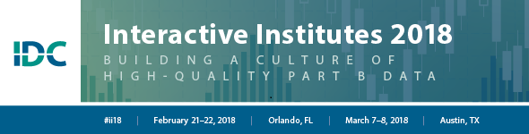

“Taking Data Processes Documentation to the Next Level” discussion notes
Reason(s) for doing the work – | Anticipated benefits – | People to have at the table –
Champions for this work – | Engaging participants – | Practices/Activities for sustainability and extension –

