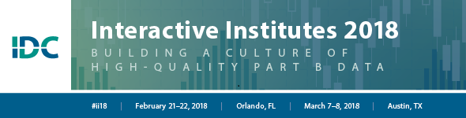

Putting Data to Work: Using IDEA Data With Stakeholders

Data Notes
Evaluation question:
- Are teachers implementing the reading program with fidelity?
- What factors are facilitating implementation and what factors are hindering implementation?
Data being analyzed:
- Fidelity observation tool
- Teacher survey
Group observations:
Interpretations:
Implications for work:

