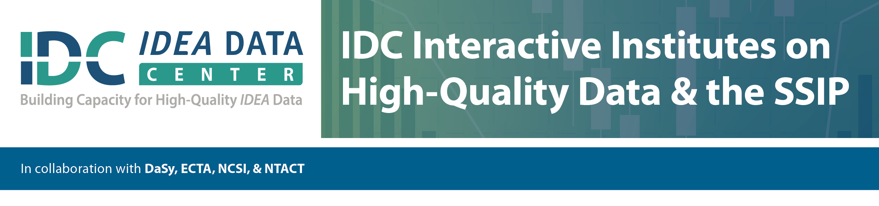

**Session G9: Collecting and Using Data on Improvement Strategies**

|  |  |  |  |
| --- | --- | --- | --- |
| **Improvement strategy** | **Existing Data: Is the strategy being implemented (and how)?** | **Existing Data: Is it having the intended outcome (and how)?** | **Data Needed/Potential Data Collection** |
|  |  |  |  |
|  |  |  |  |
|  |  |  |  |
|  |  |  |  |
|  |  |  |  |
|  |  |  |  |
|  |  |  |  |
|  |  |  |  |