Implementation Teams
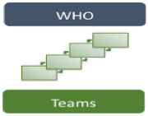
- Implementation teams provide an internal support structure to move selected programs and innovations through the stages of implementation.
- Ideal core competencies of an Implementation Team include:
  - Knowledge and understanding of the selected program or innovation including the linkage of components to outcomes
  - Knowledge of implementation science and best practices for implementation
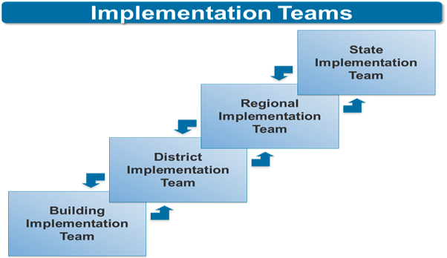
  - Applied experience in using data for program improvement
Implementation Teams focus on:
- Increasing “buy-in” and readiness
- Installing and sustaining the implementation infrastructure
- Assessing and reporting on fidelity and outcomes
- Building linkages with external systems
- Problem-solving and promoting sustainability

Examples of Implementation Teams:
Part C Example | Part B Example
State – State SSIP Leadership Team, ICC, State Implementation Team  - State leadership team may be made up of representatives from the State Staff, State ICC and other key stakeholders. In some cases the ICC may serve as the Implementation Team or identify a few of their members to serve.  Local- Regional SSIP Leadership Team, LICC, Regional Coordinators  - At the local level there may be a LICC who appoints an implementation team or Regional Coordinators may serve that role | State – Cross-Department State Implementation team; Stakeholder team; Regional Team  - State leadership team may be made up of State Staff representatives from multiple departments especially those with key state initiatives, State Special Education Advisory Commission, lead representatives from LEAs and other key stakeholders  Local – District Implementation team; Building Implementation team  - Local teams at the district level would include representatives of district and site administration across departments, teachers, related services, parents and other key stakeholders.

Discussion with Team: What examples do you have from your state:
Part C | Part B

Usable Interventions
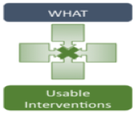
To be usable, it’s necessary to have sufficient detail about an intervention. With detail, you can train educators to implement it with fidelity, replicate it across multiple settings and measure the use of the intervention. Interventions need to be teachable, learnable, doable, and be readily assessed in practice. The following criteria need to be in place to ensure that your intervention is usable:
- Clear description of the program
- Clear essential functions that define the program
- Operational definitions of essential functions
- Practical performance assessment

Examples of Usable Interventions:
Part C and Part B Example
- Establish a state team to lead implementation.  - Involve a representative Stakeholder Group.  - Analyze the current system and document the need for change.  - Establish the target population and the outcomes to address the needs.  - Explore potential innovations that could address needs.  - Utilize a process for selection of improvement strategies related to the innovation such which includes a review of need, fit, resource availability, evidence, readiness for replication, and capacity to implement.  - Select the option(s) that fit the mission, and resources of system stakeholders.  - Secure commitment from agency (or cross agency) leadership. | - Develop a clear description of the proposed improvement strategy, including identification of core components and process for developing operational definitions of each component.  - Define the assessment for each strategy or a plan for developing these over time.  - Include a plan for identifying supports for implementation including: training, coaching, fidelity measure outcomes, progress monitoring, and alignment among teams.  Comprehensive Improvement Strategies to include:  - Identification of viable intervention.  - Development of implementation plans for each level.  - Development of team structures at each level.  - Development of communication plans and protocols.  - Development of training plans.  - Development of fidelity and performance measures

Discussion with Team: What examples do you have from your state:
Part C | Part B
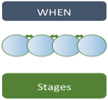
Implementation Stages
Implementation is a process involving multiple decisions, actions, and corrections to change the structures and conditions necessary to successfully implement and sustain new programs and innovations. Implementation is “a specified set of activities designed to put into practice an activity or program of known dimensions”. These activities occur over time in stages that overlap and that are revisited as necessary. Often stages overlap with activities related to one stage still occurring as activities related to the next stage begin. The stages may be revisited when circumstances change. The stages include:
- Exploration Stage - Assessing the needs of students, identifying possible programs and practices to meet those needs, assessing the fit and feasibility of implementing and sustaining the identified programs
- Installation Stage - Developing communication pathways, ensuring financial and human resources are in place, finding physical space, purchasing equipment and technology, developing practitioner competency
- Initial Implementation Stage – Involves special attention to coaching, continuous improvement and rapid cycle problem solving, initial implementation stage begins when the new program or practice is first being put to use.
- Full Implementation Stage – Involves teachers skillfully employing new practices, developing an infrastructure to support teachers, integrating new learning at all levels in classroom building and district.
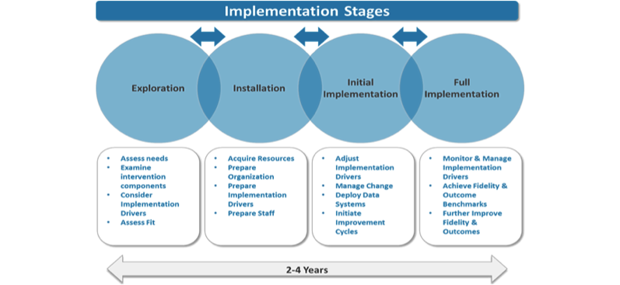
Sustainability – Planning for sustainability needs to be an active component of every stage and attention to both financial and programmatic sustainability are require. Building sustainability requires an ongoing process of providing timely and effective training and coaching, use of fidelity measurement processes, use of data-driven decision-making for continuous improvement and problem solving, and ensuring that policies and procedures continue to support and facilitate full implementation.

Examples of Implementation Stages:
Part C and Part B Example
Exploration –  - Establish a state team to lead implementation with a representative Stakeholder Group.  - Analyze the current system and document the need for change.  - Explore potential innovations that could address needs and select the option(s) that fit the mission, and resources of system.  - Secure commitment from cross-agency leadership.  Installation -  - Developing communication pathways.  - Ensuring resources are in place.  - Finding physical space.  - Purchasing equipment and technology.  - Developing practitioner competency through training and coaching. | Initial Implementation –  - Develop coaching to support staff as they implement.  - Utilize a continuous improvement and rapid cycle problem solving process to make adjustments.  Full Implementation -  - Staff are skillfully implementing new practices.  - An infrastructure to support staff is in place.  - Process exists to integrate new learning at all levels.  Sustainability  - Ensure that the funding streams for delivering the new practice are established, adequate & sustainable.  - Ensure that the implementation infrastructure is established, reliable, effective, and sustainable.

Discussion with Team: What examples do you have from your state:
Part C | Part B

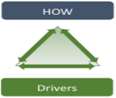
Implementation Drivers
Implementation Drivers are the components of infrastructure needed to develop, improve and sustain the ability of teachers and staff to implement an intervention as intended as well as create an enabling context for the new ways of work. Drivers are the common features of successful supports needed to make full and effective use of innovations that will benefit students and their families. There are three types of Implementation Drivers:
- Competency Drivers – involve activities to develop, improve, and sustain teachers’ and administrators’ ability to put programs and innovations into practice to benefit the students. The four competency drivers include: selection, training, coaching and performance assessment.
- Organization Drivers - are used to intentionally develop the supports and infrastructures needed to create a hospitable environment for new programs and innovations. These supports may need to be developed across the building and district levels. Components include: Decision-Support Data Systems, Facilitative Administration, Systems Interventions
- Leadership Drivers - are focused on the role rather than the authority position of a leader. We emphasize technical and adaptive leadership.
When integrated and used collectively, these drivers ensure high fidelity and sustainable program implementation.

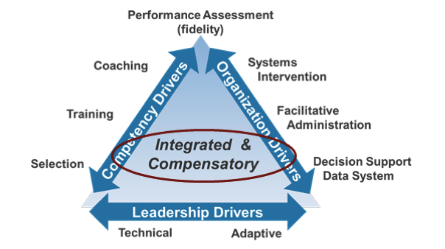

Examples of Implementation Drivers:
Part C Example | Part B Example
This is a basic example of the implementation drivers for the starting point of professional development (PD) on Child Outcomes Summary.  - Competency:  - State Team chooses assessment practices from DEC recommended practices and plans implementation. Once the PD was identified and selected, staff would provide the PD through training, webinars, selected readings. Coaching is provided to the team on the COS process. A supervisor may provide reflective supervision on the COS process, or review a COS form.  - Organizational:  - Decision Support Data System – Identify and select an assessment tool that clearly assesses social emotion development.  - Leadership:  - Lead Agency accesses funding for purchasing assessment tools and provides guidance related to assessment practices. After the PD is provided, a supervisor may review a teams COS forms for a period of time, a checklist may be put in place. | This is an example of implementation drivers for the starting point for professional development (PD) on early literacy for the selected subgroup identified in the SiMR.  - Competency:  - Cross-departmental State Implementation team selects staff with the necessary skills and abilities to provide the PD.  - Staff are provided training and coaching to ensure their competence to provide the PD.  - Performance assessment is in place to measure fidelity and effectiveness of the PD.  - Organizational:  - Data-driven decision-making processes in place to identify effectiveness of PD.  - Administration utilizes feedback loops to reviews data to make adjustments where necessary and development communication processes to ensure all are informed.  - Systemic structures are developed and revised where necessary to support implementation.  - Leadership:  - Implementation team ensures that both technical issues (purchasing, materials, staff are trained and supported, consistent guidance is provided to the field) and adaptive (revisions are made based on data) decisions are in place.
Discussion with Team: What examples do you have from your state:
Part C | Part B

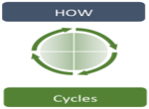
Implementation Cycles
Improvement Cycles support the purposeful process of change. Implementation teams use improvement cycles to change on purpose. Improvement cycles are based on the Plan, Do, Study, Act process.
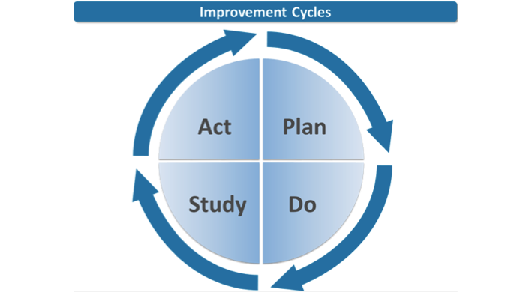
- Plan — identify barriers or challenges, using data whenever possible, and specify the plan to move programs or interventions forward as well as the outcomes that will be monitored.
- Do — carry out the strategies or plan as specified to address the challenges,
- Study — use the measures identified during the planning phase to assess and track progress, and
- Act — make changes to the next iteration of the plan to improve implementation.

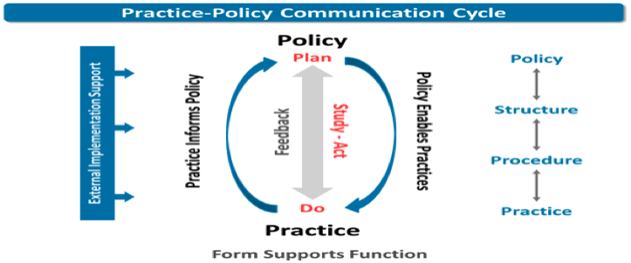

Examples of Implementation Cycles:
Part C Example | Part B Example
Improve the assessment practices with emphasis on social emotional development.  - Plan: Identify and chose the assessment tool that includes items on social emotional development.  - Do: Provide training for staff on use of the assessment tool and assessing social emotional development. Implement feedback loops to follow up on implementation of new assessment practices.  - Study: Review the training evaluation results and incorporate feedback.  - Act: Modify guidance on expected requirements for completing the assessment is disseminated to staff. | Improve the literacy in students in 3rd grade with emphasis on evidence-based early literacy skills.  - Plan: Identify and select the evidence-based literacy strategies for young children and address the targeted outcome identified in the SiMR.  - Do: Provide training for staff on use of the strategies. Implement feedback loops to follow up on implementation of new literacy strategies.  - Study: Review the training evaluation results and outcome measures and incorporate feedback into the feedback loops.  - Act: Modify strategies and activities based on the evaluation and outcome data.

Discussion with Team: What examples do you have from your state:
Part C | Part B

