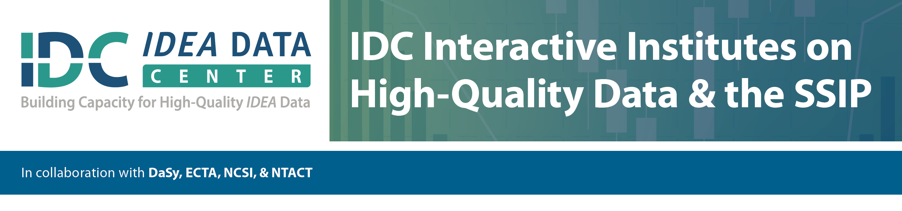

Purpose of the data collection/analysis:

Description of the general topic of the data collection/analysis:

Details for planning and conducting the data collection/analysis:

What?

Why?

How?

Documentation of decisions/findings