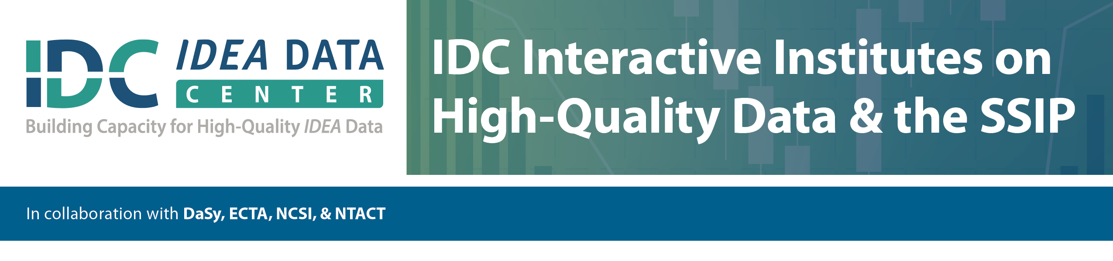

Essential Questions for Consideration in the Planning, Designing, Implementing, and Sustaining of instructional programs in mathematics to improve the learning outcomes of students with disabilities.

1. What is the current status of your state relating the 3 Main Pillars?
   * Standards, Curriculum, and Interventions
   * Assessments and Data-based Decisions
   * Teacher Content and Instructional Knowledge
2. Assessments and Data Based Decisions
   * Who is administering the assessments?
   * How is the data being shared?
   * How is the data being analyzed?
   * What instructional decisions are currently being made?
   * What type of expectations are for instructional changes?
   * How is it being facilitated?
3. Instructional Support System
   * What is the current support system for struggling students?
   * Do students get extra instruction? How much? Where?
4. Instruction and interventions
   * What is the core program?
     + Reflected of the standards
   * What are the interventions?
     + Multiple levels of intervention
5. Teacher Content and Instructional Knowledge
   * Professional Development related to “shift” in state standards?
     + Grade 3-4-5 had major changes related to RATIONAL NUMBERS
   * What strategies do your teachers currently use?
     + Evidenced-based Practices described by the National Mathematics Advisory Panel.
   * What did I (the teacher) do differently for the struggling students?
     + Instructional Time
     + Scaffolding Learning
     + Building Self-Confidence